Figures for the article: Do we know enough to prevent occupationally acquired Tuberculosis in Health Care Workers?

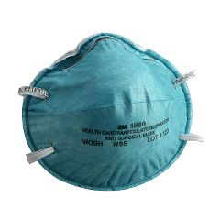
Fig 1: N95 mask, for occupational TB prevention in HCWs

