Appendix A: Embedded occupational injury prevention and management model

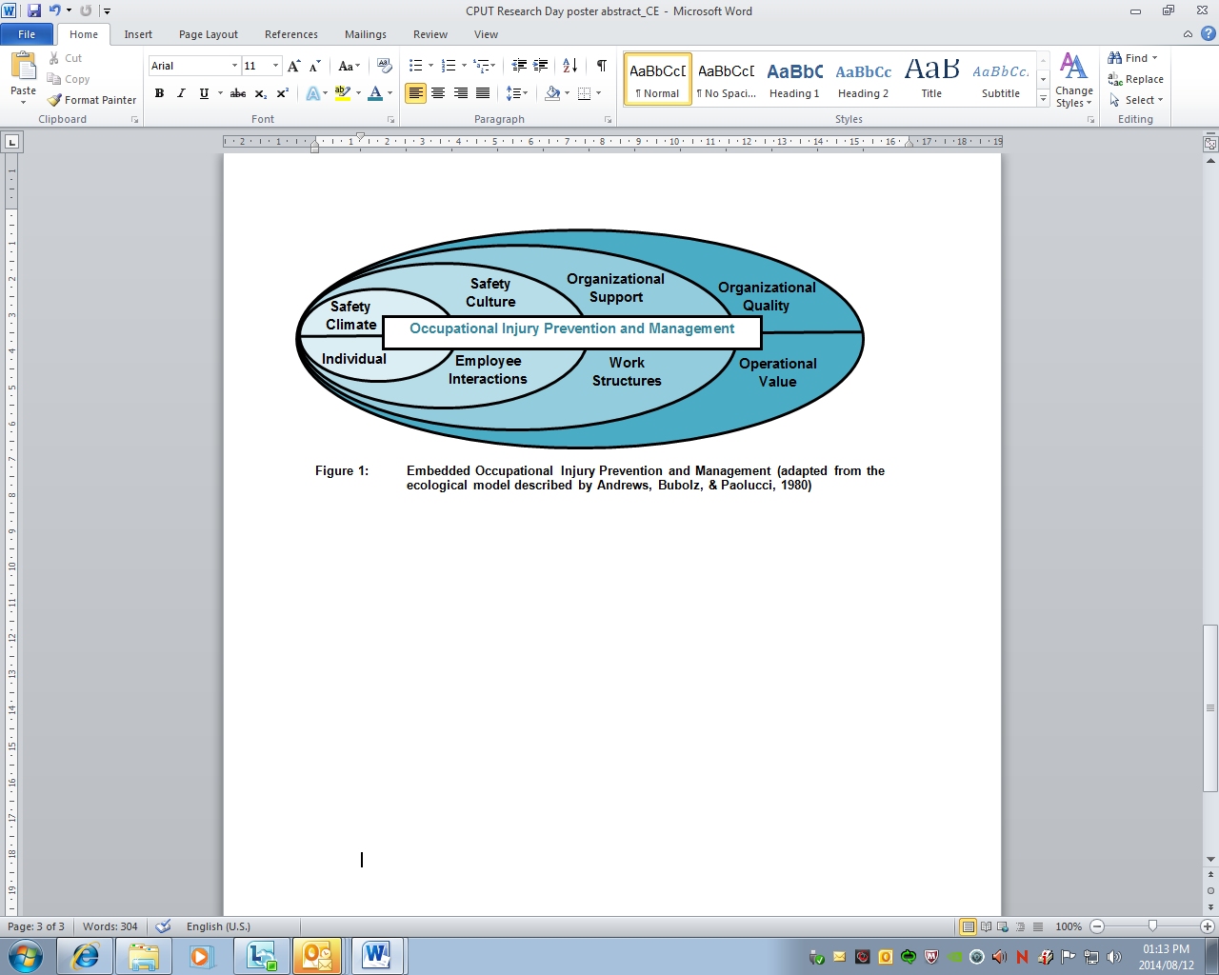
Figure 1: Embedded occupational injury prevention and management model (adapted from the ecological model described by Andrews, Bubolz and Paolucci, 1980)

Appendix B: Media reports and studies indicating risks in Higher Education
Table 1: Faculty wide risks
HEI Faculties and Departments | Risks and Hazards | Injury Studies or Media Reports
Health Science,  Science,  Research | Lack of listing of chemicals.  Lack of internal policies and guidance for workers.  Carcinogenic and toxic chemicals.  Inconsistent occupational health surveillance of students.  Poorly enforced occupationally focused service for staff.  Blood borne and airborne infections.  Inoculation injuries (sharps).  Zoonotic infections  Injuries and infections among Oceanographic researchers.  Hazardous biological agents.  Allergies (skin and rhinitis) | Venables & Allender (2006, pp. 162-164)  HSE, (HSG 257, 2006, p.10)
Engineering | Noise exceeding exposure limits causing hearing loss.  Ergonomic (Back and Upper limb disorders).  PPE use not adequately enforced.  Burns and explosions. | Menendez, Amick, Jenkins, Caroom, Robertson, Harrist & Katz (2009).  Japan Today (Feb. 20, 2014) media report.  UCLA Daily Bruin, (April 5, 2014) media report.  HSE, (HSG 257, 2006, p.10)
Humanities,  Arts | Silica in sandblasting.  Wood dust  Noise exceeding exposure limits causing hearing loss.  Toluene and Methyl cellosolve acetate in painting and printmaking.  Absence of appropriate PPE.  Machinery and tools used incorrectly and without appropriate safety guards.  Musculoskeletal disorders among professional and university student classical musicians. | Venables & Allender (2006, pp. 162-164)  HSE, (HSG 257, 2006, p.10)
Support services | PPE use not adequately enforced.  Lead exposure  Musculoskeletal disorders  Ergonomic (Back and Upper limb disorders).  Respiratory irritants.  Noise induced hearing loss.  Skin irritants. | Venables & Allender (2006, pp. 162-164)  HSE, (HSG 257, 2006, p.10)
Commerce,  Management Studies | Musculoskeletal disorders  Ergonomic (Back and Upper limb disorders). | HSE, (HSG 257, 2006, p.10)
Law | Exposure to airborne infectious diseases.  Musculoskeletal disorders  Ergonomic (Back and Upper limb disorders). | HSE, (HSG 257, 2006, p.10)

Appendix C: Safety oversights reported in health and safety committee minutes
Box 2: Health and safety meeting minutes as a problem indicator
The incident investigation revealed that cleaning staff did not use signage and a similar case revealed that where signage was used; it was placed in an obscure place where building occupants did not benefit from the use of warning signs. The seemingly minor oversight resulted in injuries on duty due to staff slipping and falling on wet floors. The importance of enforcing health and safety compliance, training staff to understand the importance of following safe operating procedures and monitoring the effectiveness of health and safety systems becomes evident from this example.

Appendix D: Injury prevention strategies at participating HE institutions
Table 2: Documented support of the OHS Management system
Official Documents | University-A |  | University-B
Official Documents | Documents available | Awareness | Documents available | Awareness
H&S Committee meeting Minutes | x | x
Health and Safety Training records | x
Health & Safety Appointments – Safety Reps | x | x
Health & Safety Appointments –  First Aiders | x | x
Health & Safety Appointments – Evacuation Marshals | x | x
Injury on Duty Procedures | x |  | x
Injury on Duty Policy
Health and Safety Policy | x | x
Health & Safety surveillance system – automated | x
Health & Safety surveillance system - manual | x | x
Health and Safety Audit documents - external
Health and Safety Audit documents - internal | x
Annexure 1 Incident Reports | x |  | x
Employers Report of an Accident | x |  | x | x
Emergency Procedures | x | x | x
Emergency Plan | x
Evacuation Plans | x |  | x
General Safety Signage | x | x
Emergency Contact Lists | x | x | x | x
Risk assessments
Public access Health & Safety Awareness info. | x
Health & Safety awareness campaigns
Health & Safety Inductions |  | x | x
Food Hygiene and Food Safety programme | x
Health & Safety training in Staff Development programs. | x | x
Total (25) | 20 | 11 | 7 | 2

